Step 1

HEALTHCARE OPERATIONS & TECHNOLOGY
Healthcare operations,
built differently.
Solid State Practice is the operations and technology engine behind AlignedCardio, combining experienced healthcare teams, analytics, automation and AI to build a better way to run medical practices.
AlignedCardio has invested in building critical operational capabilities directly into its platform, and SSP is a critical part of that infrastructure.
Learn more about AlignedCardio →

Built inside healthcare. Proven in practice.
CTA
[ Explore Our Capabilities ] [ Partner With Us ]


Step 2

120+ 12,000+ 2,000+ 60+
Healthcare Operations Patient Calls Appointments Providers
Professionals Weekly Scheduled Weekly Supported

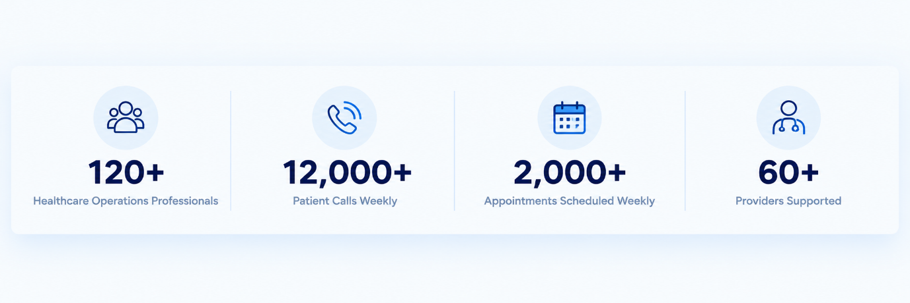

Solid State Practice was built to solve the operational challenges we encounter every day inside a growing physician-led healthcare organization. As part of AlignedCardio, SSP supports the infrastructure behind a complex, multi-market cardiovascular platform—from revenue cycle and patient access to analytics, finance, automation and AI. Our operating environment is our laboratory: we identify problems, build better workflows, deploy them in real-world healthcare settings, measure the results and continuously improve them. Today, we bring that same operating discipline and technology-enabled approach to the organizations we support.
Small supporting line / highlight
Real healthcare experience. Better operations. Technology built for what’s next.

Section 2 — Part of AlignedCardio
Part of AlignedCardio
Solid State Practice is part of AlignedCardio, a physician-led cardiovascular platform built around a simple idea: physicians and patients deserve better infrastructure. AlignedCardio has invested in building critical operational capabilities directly into its platform rather than relying entirely on multiple external vendors. SSP is a critical part of that infrastructure, bringing together experienced healthcare teams, technology, analytics, automation and AI to support better healthcare operations.
CTA
Learn more about AlignedCardio →
Reference image
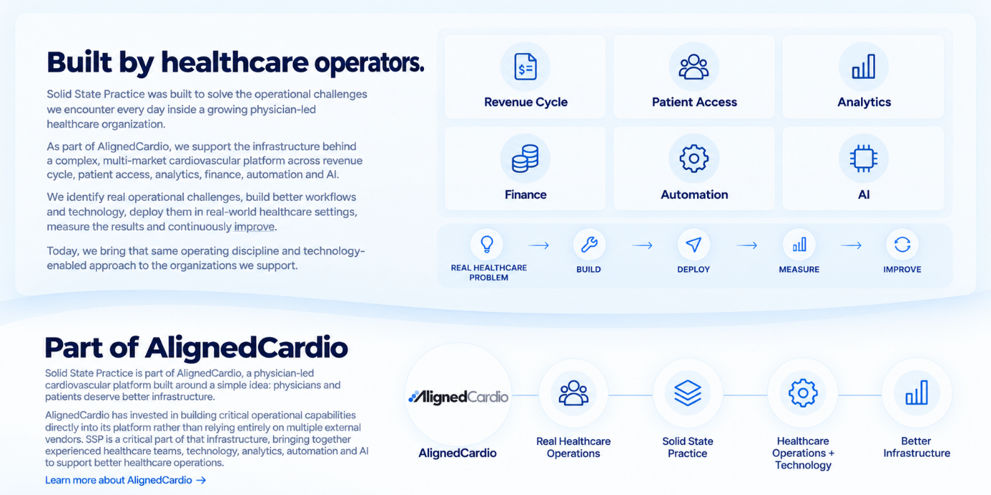

Section
- Update the new logo for Solidstate practice logo with AlignedCardio
- Change the way the services are organized

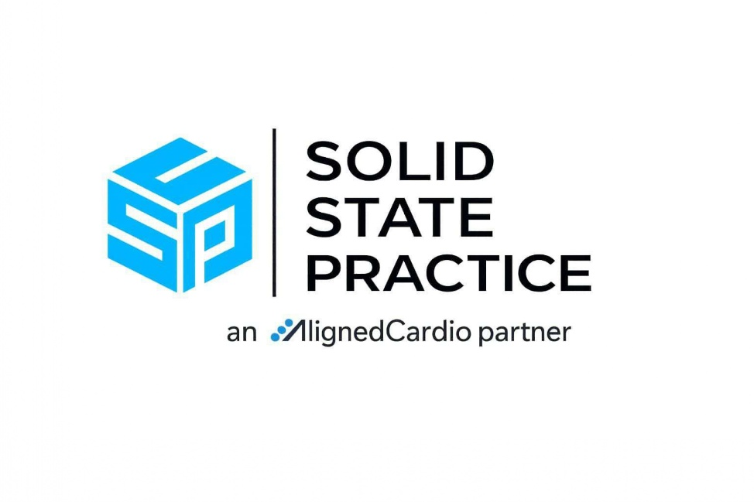

Change the way the services are organized

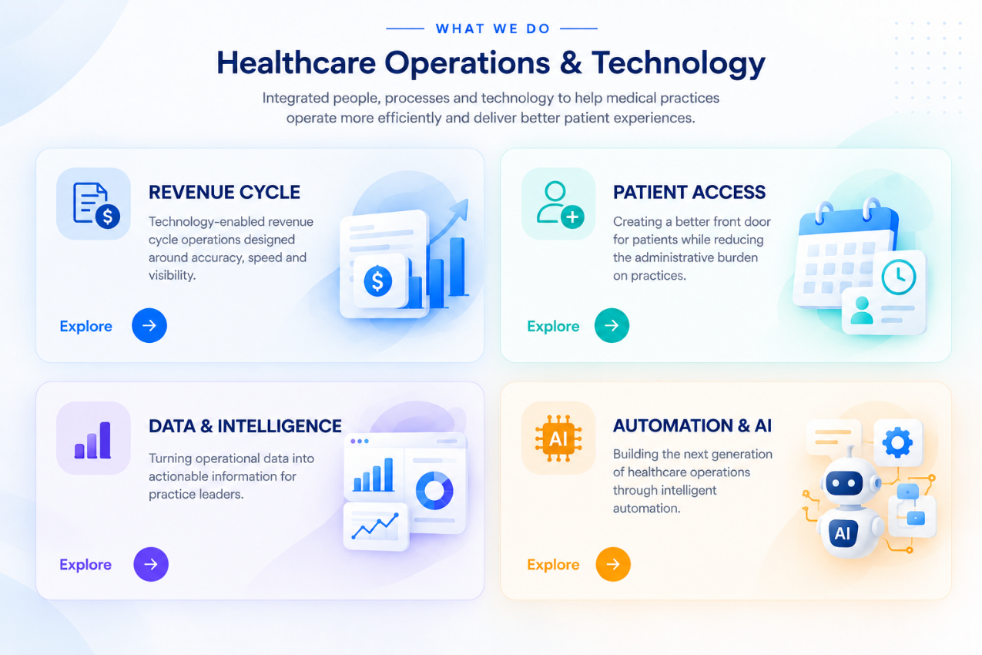

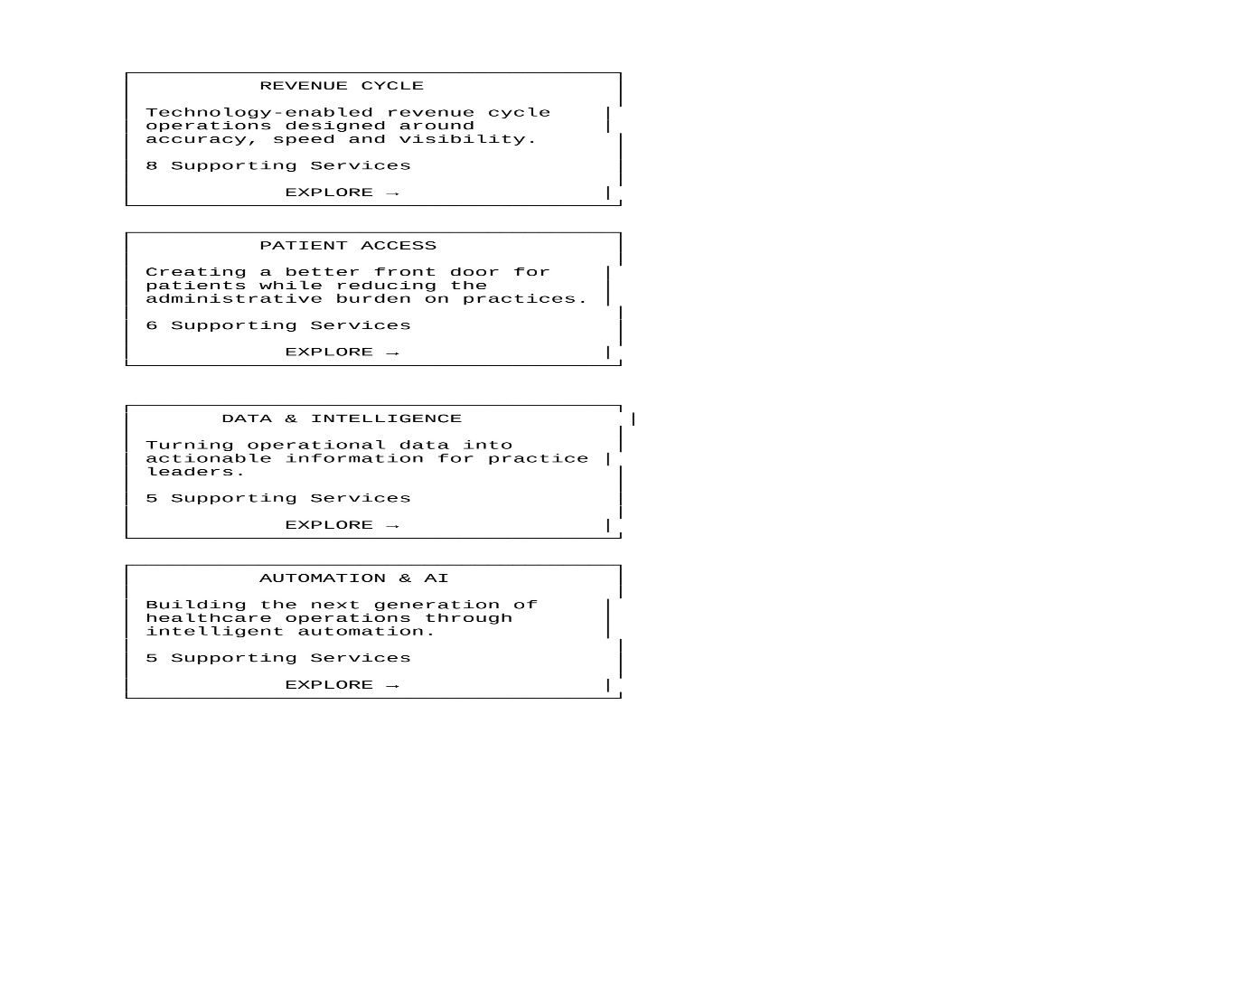
Building what’s next in healthcare operations.

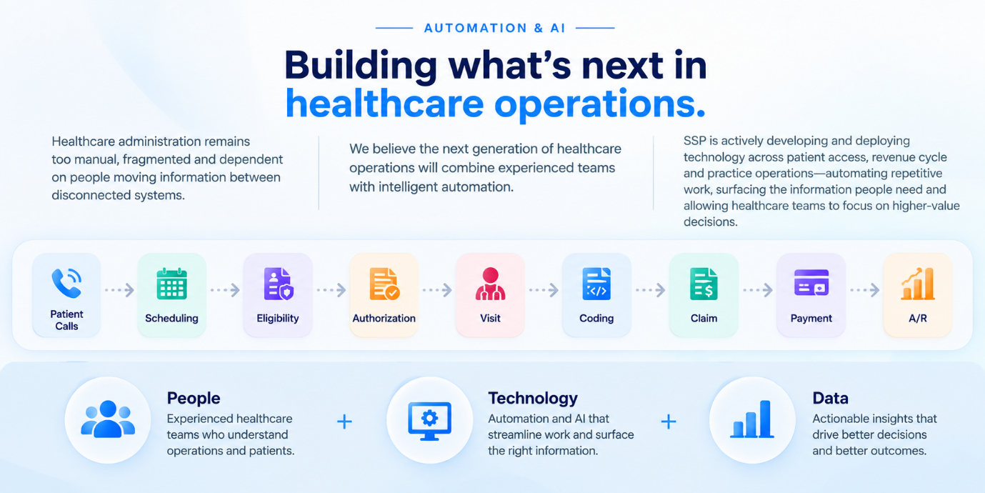

3 short content blocks
Problem
Healthcare administration remains too manual, fragmented and dependent on people moving information between disconnected systems.
SSP approach
We believe the next generation of healthcare operations will combine experienced teams with intelligent automation.
SSP is actively developing and deploying technology across patient access, revenue cycle and practice operations—automating repetitive work, surfacing the information people need and allowing healthcare teams to focus on higher-value decisions.

Patient Calls
↓
Scheduling
↓
Eligibility
↓
Authorization
↓
Visit
↓
Coding
↓
Claim
↓
Payment
↓
A/R

People
Experienced healthcare teams who understand operations and patients.
Technology
Automation and AI that streamline repetitive work and surface useful information.
Data
Actionable insights that help teams make better operational decisions.

Add a “How we innovate” section

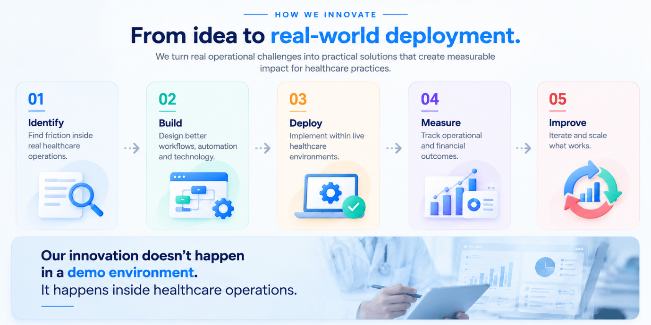

HOW WE INNOVATE

From idea to real-world deployment.

We turn real operational challenges into practical
solutions that create measurable impact for
healthcare practices.

01 — Identify
Find friction inside real healthcare operations.

02 — Build
Design better workflows, automation and technology.

03 — Deploy
Implement within live healthcare environments.

04 — Measure
Track operational and financial outcomes.

05 — Improve
Iterate and scale what works.

--------------------------------------------

Our innovation doesn’t happen in a demo environment.
It happens inside healthcare operations.

Don’t overemphasize cost savings

A BETTER OPERATING MODEL
Better performance. Greater scalability. Lower administrative cost.
SSP combines healthcare expertise, technology, automation, and data to create more efficient operating models for medical practices.
PEOPLE + TECHNOLOGY + DATA
01  Better Performance  Streamline day-to-day healthcare operations with experienced teams, connected workflows, and technology. | → | 02  Greater Scalability  Build operational capabilities that can grow with your practice and evolving business needs. | → | 03  Lower Administrative Cost  Improve efficiency and reduce administrative overhead through better processes, technology, and automation.

OUTCOME
Stronger performance, scalable operations, and greater administrative efficiency.

Reference image
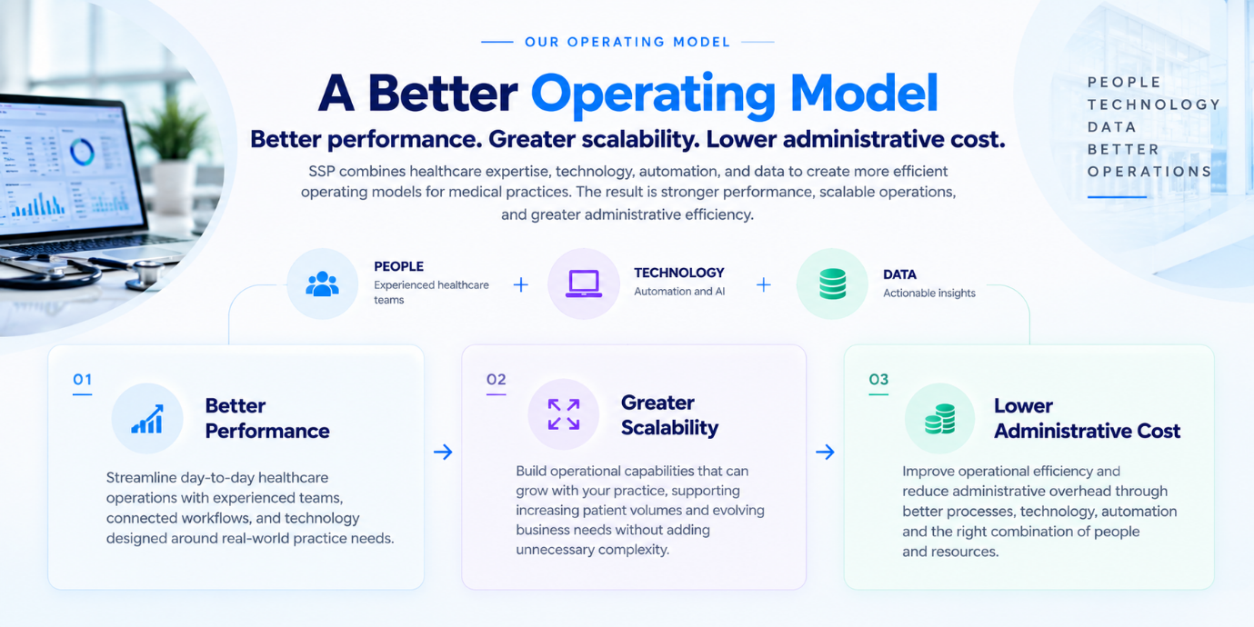
Add “Built at Scale”

Built for complex healthcare organizations.
Our teams support the operational infrastructure behind growing physician organizations across multiple locations, providers and service lines.
Capabilities
Patient Access
Patient engagement, appointment scheduling and access support.
Clinical Operations
Support for providers, care teams and day-to-day clinical operations.
Revenue Cycle
End-to-end RCM including claims, denials, A/R and collections.
Finance
Financial operations, reporting and revenue visibility.
Analytics
Data, reporting and insights to drive better decisions.
Technology
Technology-enabled workflows and automation to improve efficiency and scale.

MORE THAN BILLING
SSP supports the entire healthcare operations lifecycle — from patient access to technology.
We combine people, process and technology to help physician organizations operate more efficiently and scale with confidence.

AT SCALE
Supporting growing physician organizations.
Our teams and technology are built to handle the complexity of multisite, multi-provider and multi-service organizations.
Multiple Locations
Support across geographies
Multiple Providers
From single specialties to multi-specialty groups
Multiple Service Lines
Across cardiology and adjacent services
Growing Patient Volumes
Built to scale with your organization.

Reference image
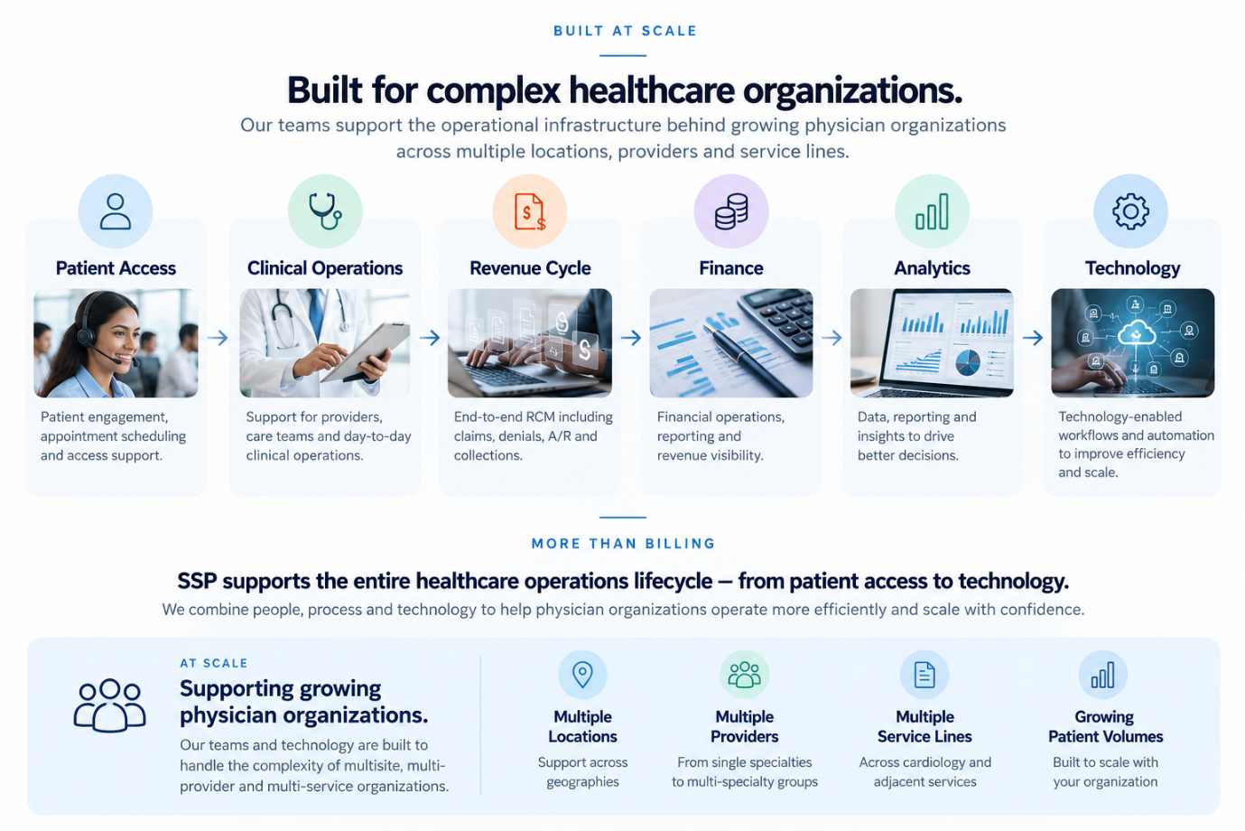

Add leadership—but selectively
Reference image


